TOP of title centered and aligned to line — page 1
(Title font: Times New Roman 14 points)

Author(s) name(s) centered and aligned to line — page 1
Author affiliation(s), e-mail addresses centered below names
Font: Time New Roman 10 points

Abstract

This is the area of the abstract of my paper. It must fit within the size allowed, which is in the area between dashed lines at maximum. The font is Times New Roman 10 points italic.

Keywords: word1, word2, word3, word4.

1. Introduction
Here is my introduction text. The section heading is in a large bold font and all sections and subsections are numbered.
Type your main text in 10-point Times New Roman, single-spaced. Do not use double-spacing. Be sure your text is fully justified---that is, flush left and flush right. Please do not place any additional blank lines between paragraphs. Please keep all text and graphics within the column margins

2. Previous Works
Throughout the manuscript I may cite references of the form [1], [2] or [3]. The numbers are based on the order you place them in the bibliography, not the order they appear in the text. The references should be in alphabetical order.

3. Equations and Figures
Equations and figures must be numbers based on the order they appear in the text.

3.1. Equations

$w_{i}^{\text{new}}=w_{i}^{\text{old}}+{Dw}_{i}$ (1)
${Dw}_{i}=e⋅h_{λ}\left(k_{i}\left(v,w\right)\right)⋅\left(v−w_{i}\right)$ (2)

3.2. Figures

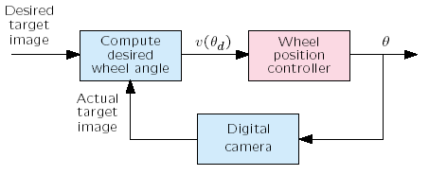
Figure 1. Visual navigation of mobile robot.

4. Conclusion
This template will get you through the camera ready manuscript for the IES2013. Please remember that the manuscript is limited to maximum 6 pages.
See you in Surabaya.

References
[1] I. M. Author, ''Some Related Article I Wrote'', Some
Fine Journal, Vol. 17, No.1, pp. 1-100, 1987..
[2] A. N. Expert, A Book He Wrote, His Publisher, 1989.
[3] D. N. Semi, ''An Article She Wrote in a Conference'',
Proc. 14th International Conference on Pattern Re-
cognition, vol.1, pp.120-130, 2000.

